**Capstone Project : House Price Prediction : Milestone Report**

1. Write a your capstone project 1 milestone report (Google Doc, 5-6 pages) and include the following:
   1. Problem statement: Why it’s a useful question to answer and for whom (get this from your proposal)

To predict the house price based on the training data provided, using linear regression technique

* 1. Description of the dataset, how you obtained, cleaned, and wrangled it (get this from your data wrangling report)

The datasets, test and train, csv files were obtained from Kaggle repository. The datasets were pretty much clean. And we are generally using GrLivArea, TotalBsmtSF and OverallQual variables to predict the SalePrice

* 1. Initial findings from exploratory analysis (get this from your data story and inferential statistics reports)
     1. Summary of findings

We see that GrLivArea and TotalBsmtSF seem to be linearly related with SalePrice. Both of them have postive effect. When one increases, the SalePrice also increases. TotalBsmtSF seem to have steeper gradient though. OverallQual and Year built are also positively corelated. However, the relationship seems to be stronger between OverallQual and SalePrice

* + 1. Visuals and statistics to support findings

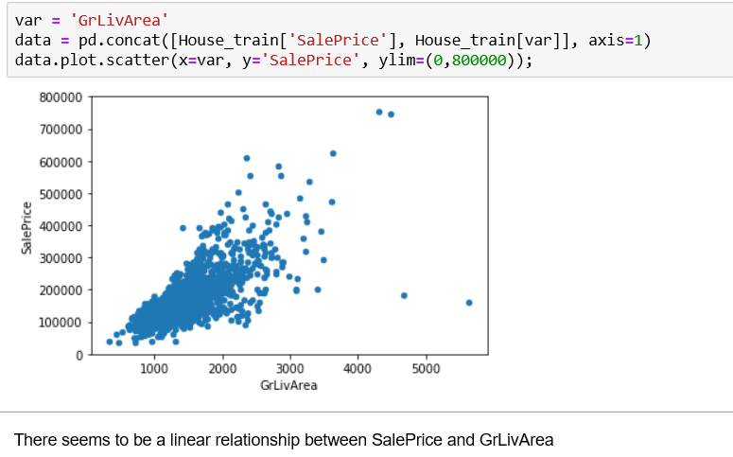

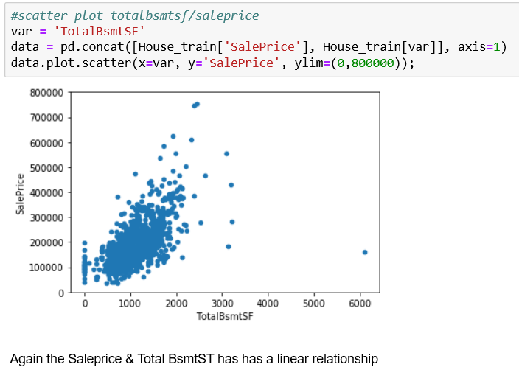

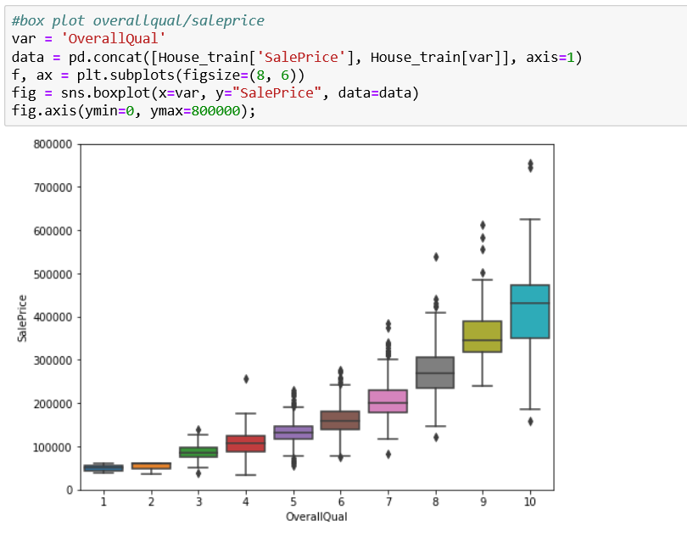

* Are there strong correlations between pairs of independent variables or between an independent and a dependent variable?

Yes, OverallQual has a very strong relationship and positively co-related.

Similarly, TotalBsmtSF also has a steep gradient indicating that steep increase in sale price with increase in TotalBsmtSF

* What are the most appropriate tests to use to analyse these relationships?

Appropriate tests to analyse these relationships are generating the Co-relation Matix and Co-relation Co-efficient to determine how positively or negatively the variables are related.

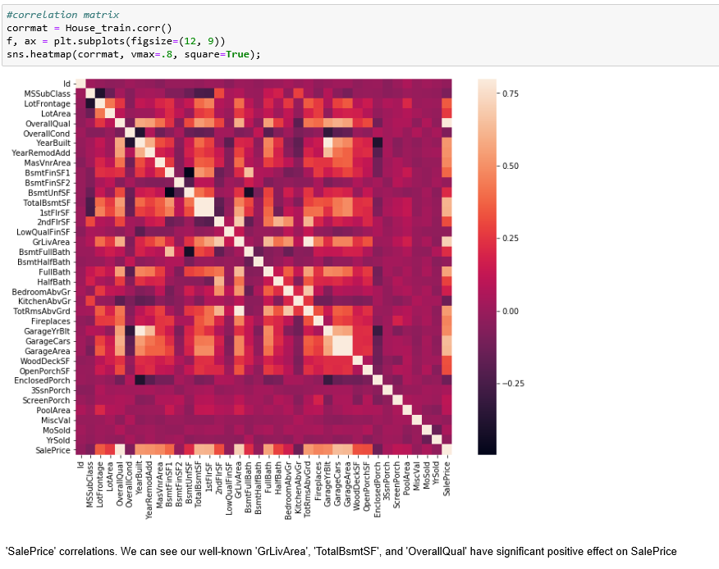

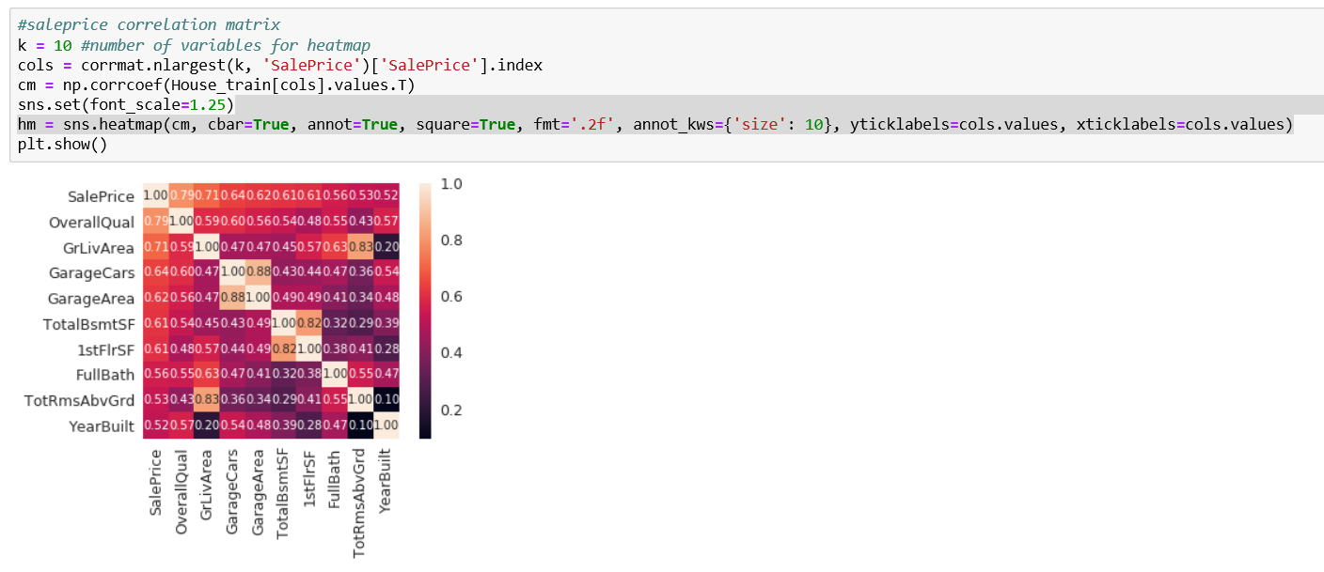

1. Update your presentation slides.

Done

1. Update your GitHub repository with the capstone project 1 code, milestone report, document, and slides .

done

1. Use the link below to share your report with your mentor for feedback, and update as needed.

done

1. Convert to .pdf and add to your repository. Share with your peer community.

done